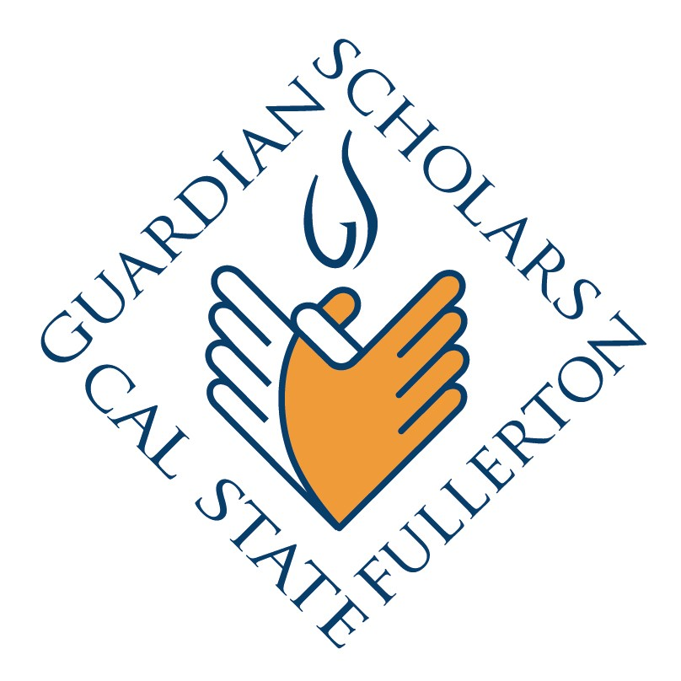
Services Provided
Once admitted to Cal State Fullerton and accepted in the Guardian Scholars Program, participants are awarded scholarships for tuition, fees, textbooks, and supplies. Beyond these basics, the following additional support services are provided:

- Year-round on-campus housing: Guardian Scholars are given priority for safe and affordable housing in the residence halls.
- Financial Assistance: Guardian Scholars receive additional financial support not covered by state and federal aid through private funding.
- Admissions Services: Assistance with completion of admission requirements are provided during program application process.
- New Student Orientation: Both incoming freshmen and transfer Guardian Scholars are provided academic advisement, campus and program orientation.
- Summer Bridge: Provide essential academic advisement services for Guardian Scholars.
- Student Drop-In Center: A confidential and safe place for Guardian Scholars to study and network with other students in the program.
- Counseling and Support: A tremendous amount of time to providing a safe and nurturing environment for students to share their personal concerns and issues.
- Priority Registration: Guardian Scholars register early to ensure their educational plan and graduate within 5 years.
- Early Alert: Mid-semester grade reports help students track their academic progress.
- Life Skills Workshops: Topics include Money Management, Business Etiquette, Stress Management and Safety. Workshops are facilitated by experts in the field.
- Community Enrichment Activities: Consistently provide student opportunities to interact with one another in a stress free and fun environment.
- Employment: On campus student employment is encouraged. As an added benefit, they learn time-management in a supportive but carefully supervised environment.
- Career Mapping Program: Career planning aimed to prepare Guardian Scholars to transition from college student to career professional.
- Health Services: Basic health and counseling are provided at no cost at the campus Student Health and Counseling Center. In addition guardian scholar community partners provide medical and dental services not covered on campus.
- Disabled Students Support: Provide assessment and support for Guardian Scholars with learning differences.
- Childcare: For those students who are a single parent, Guardian Scholars receive priority reservation at the University Children’s Center.
- Digital Stories: Through the Center for Digital Stories, students undergo an intensive four day workshop. Students learn to utilize multimedia applications such as photos, video, music and poetry in order to produce a personal story.

