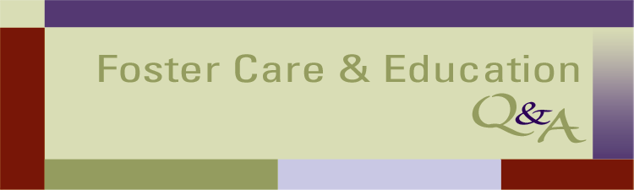

HOW CAN CHILD WELFARE AGENCIES GET EDUCATION INFORMATION ABOUT CHILDREN IN THEIR CARE?

Q: Why is it important to share educational information among child welfare and education agencies and the courts?

A: Sharing child-specific and aggregate level data among child welfare, education, and court systems can improve the systems and help children. With current information from the child’s education records, the child welfare worker can make better decisions about a child’s placement, well being, and transition goals. The judge can make sure that the child is enrolled in school and is getting needed additional supports. Aggregate data can increase accountability among state and local agencies. And, reliable statistics can help stakeholders advocate for better laws and policies and increased funding.

Q: What is FERPA and what is the Uninterrupted Scholars Act?

A: Schools must comply with the Family Educational Rights and Privacy Act (FERPA). In general, FERPA prohibits schools from disclosing personally identifiable information from a student’s education records to a third party unless the parent (or the student at age 18) gives written consent. So, whenever feasible, the first step in getting a student’s education records should always be to seek the parent’s consent. FERPA regulations define a parent as “a parent of a student and includes a natural parent, a guardian, or an individual acting as a parent in the absence of a parent or guardian.”

FERPA has a number of important exceptions to the “no disclosure without consent” rule. The most important for child welfare agencies is a new amendment to FERPA called the Uninterrupted Scholars Act (USA). Under this new “child welfare exception,” schools are now permitted to release a child’s education records to an agency caseworker or other representative of a state or local child welfare organization or a tribal organization when the agency or organization is “legally responsible…for the care and protection of the student” and has the right to access a student’s case plan. While this includes children placed in out-of-home care by a child welfare agency, states may vary as to whether some child welfare-involved students living at home may also fall within the coverage of this amendment. For more information about USA, see http://www.fostercareandeducation.org/database.aspx?EntryID=1833&command=core_download&method=inline

Q: To what extent can education records obtained under the new “child welfare exception” be shared with third parties?

A: Child welfare agencies can only disclose education records obtained pursuant to the child welfare exception to “an individual or entity engaged in addressing the student’s education needs” who is authorized by the child welfare agency to receive the records and consistent with other state confidentiality rules. This could include a reading specialist whom the agency has asked to evaluate the child. Or, regardless of whether there is an explicit court order, education records and personally identifiable information from those records could be disclosed to the child’s foster parent, the GAL, a CASA volunteer, or another person whose job includes engaging with the school or working to improve the child’s education.

Q: Can a school release education records to comply with a court order, and how did USA change this exception?

A: Yes. A school can release education records to any party listed on a court order or subpoena, such as the caretaker, children’s attorney, or court appointed special advocate. Under the USA, schools do not need to give notice to the parents prior to the release of education records under this exception when the parents are already parties to the child welfare case where the order is entered, and thus are already on notice that the school records will be shared.

Q: Is there any child-specific information that schools can release without parental consent?

A: FERPA permits the disclosure of “directory information” without parental consent after the school gives general notice to all parents of its intent to release directory information. Directory information can include: student’s name, address, telephone listing, email, date and place of birth, grade level, dates of attendance, degrees and awards received, and the most recent educational agency attended by the student. Directory information may also include a student ID number or other unique personal identifier, but only if the identifier cannot be used to gain access to education records except in conjunction with a password or other factor known or possessed by the authorized user. It may not include a student’s social security number.

Q: Are there other FERPA exceptions that can help child welfare and education systems share student information for statistical purposes?

A: In many cases, statistical information will not be “personally identifiable” and therefore will not trigger FERPA at all. Moreover, the FERPA regulations were amended in December 2011 to help systems share data related to all students. Nothing in the USA changes the scope of this exception. State and local education entities can now release personally identifiable student information to an “authorized representative” (which can include a child welfare agency) for an “audit or evaluation of Federally-supported education programs.” An “education program” includes an early childhood education or career and technical education program operated by a non-education agency. Education agencies can also disclose personally identifiable student information to organizations (including federal, state, and local agencies and independent organizations) conducting studies to develop, validate, or administer predictive tests; administer student aid programs; or improve instruction. For more details on these changes, see http://www.fostercareandeducation.org/database.aspx?EntryID=1313&command=core_download&method=inline

Q: Where can I learn more about this topic?

A: The Legal Center for Foster Care and Education provides training and technical assistance on data and information sharing. We provide examples of what has worked in other jurisdictions, assess legal strategies, and assist in drafting memoranda of understanding that delineate the role of each stakeholder, protect children’s and families’ privacy rights, and ensure quality and reliability. For training and technical assistance requests, please email ccleducation@americanbar.org. For a manual and tools about information sharing between child welfare and education, please download Solving the Data Puzzle at http://www.fostercareandeducation.org/database.aspx?EntryID=1543&command=core_download&method=inline

