School of Origin Best Interest Determination Procedures & Worksheet
Before recommending that a foster youth move from their school of origin, the district must provide a written explanation of why a school change is in the youth's best interests, and obtain a written waiver from the ERH. The following steps guide a determination of whether a youth should remain in the school of origin or should transfer to a new school, and what plans are needed to ensure continuous school enrollment.

Student Name: Current Grade: Date of Meeting:
STEP 1: Meeting Participants
Education Rights Holder(s) (“ERH”) Present? Name:
Mandatory Participant
Student Present? Name:
Caregiver(s), if different than ERH Present? Name:
Social Worker/Probation Officer Present? Name:
Minor’s Attorney/Public Defender Present? Name:
Foster Youth Counselor/Liaison Present? Name:
Academic Counselor Present? Name:
School Administrator Present? Name:
Other Present? Name:
Other Present? Name:

STEP 2: Identify School Options
Option 1: School student attended before home placement change, or current school if student has not yet moved: .
Option 2: School of residence after home placement change: .
Option 3: School attended when student first entered foster care/probation system: .
Option 4: Any other school(s) attended within the last 15 months where the student has a connection:
.
Option 5: Any school(s) to which the student would have matriculated (elementary to middle or middle to high school) from options 1-4 above, using district feeder patterns: .

STEP 3: Complete Best Interest Analysis By Considering Pros And Cons Of School Of Origin Options
Discuss the pros and cons of each school using the chart below. First, write in the name of each school of origin option (identified in Step 2 above) into the top row. School Option 1, the student’s current school (or the school the student attended before the home placement change), is shaded grey to remind meeting participants that it is strongly favored, especially if the student has experienced significant school instability in the past and/or has struggled to recover after past school changes. Then, discuss with the team which school or schools best answer each question and place an “X” in the appropriate box(es).

 | Option 1 | Option 2 | Option 3 | Option 4 | Option 5
Name of School
Student Preference
What school(s) does the student want to attend?
Length of Attendance
Which school(s) has the student attended long enough to develop relationships, trust, and a feeling of belonging?
Which school(s) would the student like more time at to continue their development of positive relationships and/or academic progress?
Academic Strengths
Which school(s) has the strongest academic program and/or college going culture to support the needs of the student?
If the student has academic challenges, which school(s) has a robust intervention program to support the needs of the student?
Which school(s) has an academic emphasis or program of interest to the student?
Special Education
If the student has an IEP, which school(s) can provide the most appropriate program?
English Learner
If the student is an English learner, which school(s) can best support the student’s language development needs?
Social/Emotional
At which school(s) has the student developed positive relationships with peers and/or teachers?
 | Option 1 | Option 2 | Option 3 | Option 4 | Option 5
If the student has experienced difficulties with peers or staff, which school(s) is free of those negative experiences?
Which school(s) has positive behavioral programs, restorative justice, or other schoolwide social-emotional interventions in place?
If the student would benefit from it, which school(s) provides access to school-based counseling?
Timing of Transfer
Which school will prevent a mid-semester school change? (Check only the school where the student is currently attending)
Consistency of Curriculum
Which school(s) uses the same curriculum or set of standards as the most recent school?
Which school(s) follow the same graduation requirements as the most recent school?
Anticipated Length of Placement
If the student is in (or about to be placed in) a permanent living situation (e.g., with a relative or someone seeking legal guardianship or adoption of the student), which school(s) would also work for that home placement?
Extracurricular Activities
Which school(s) will) enable the student to be connected to extracurricular activities?
School Discipline
At which school(s) does the student have positive behaviors (free or minimal discipline history)?
Which school(s) has identified positive ways to address future disciplinary issues?
Which school(s) are within 15 miles of the new placement?
What is the school schedule? (Start time / End time) | ____/____ | ____/____ | ____/____ | ____/____ | ____/____
Impact of Distance on Education
How long is the student willing to spend in transit each day? ____ minutes
How early is the student willing to leave for school? ____ AM
How late is the student willing to get home from school? ____ PM
STEP 4: Foster Youth Liaison Recommendation
The youth's AB 490 Education Liaison: recommends or does not recommend that the youth remain in their school of origin for the following reasons:

.

STEP 5: ERH Best Interest Determination
The ERH makes the final decision about whether remaining in the current school or any other school of origin is in the student’s best interest, based on the completion of the chart, all the information available to the team, the Foster Youth Liaison’s recommendation, and what the ERH believes would best serve the youth’s needs.

ERH Chooses: to have the youth remain in school of origin OR
to waive the youth’s right to remain in their school of origin and requests immediate enrollment at: school. (skip to Step 7 for consent)

STEP 6: Transportation Plan
If the ERH decides that attendance at a school of origin is in the best interests of the student, use the Transportation to School of Origin Flowchart on the next page to identify whether the school or child welfare/probation agency will be responsible for providing that transportation and in what form (e.g., reimbursement, bus service, public transit pass, etc.).³ The child welfare/probation agency and school district may also agree to split certain costs for transportation at the end of each year.

³ Under the Every Student Succeeds Act, the written procedures describing transportation cost splitting must also describe how disputes regarding school of origin will be addressed and who will pay while the dispute is ongoing. Best practices suggest that for ease of implementation, the school of origin district where the youth already has been attending should pay for transportation in the first instance, seeking reimbursement as appropriate after the dispute is resolved.
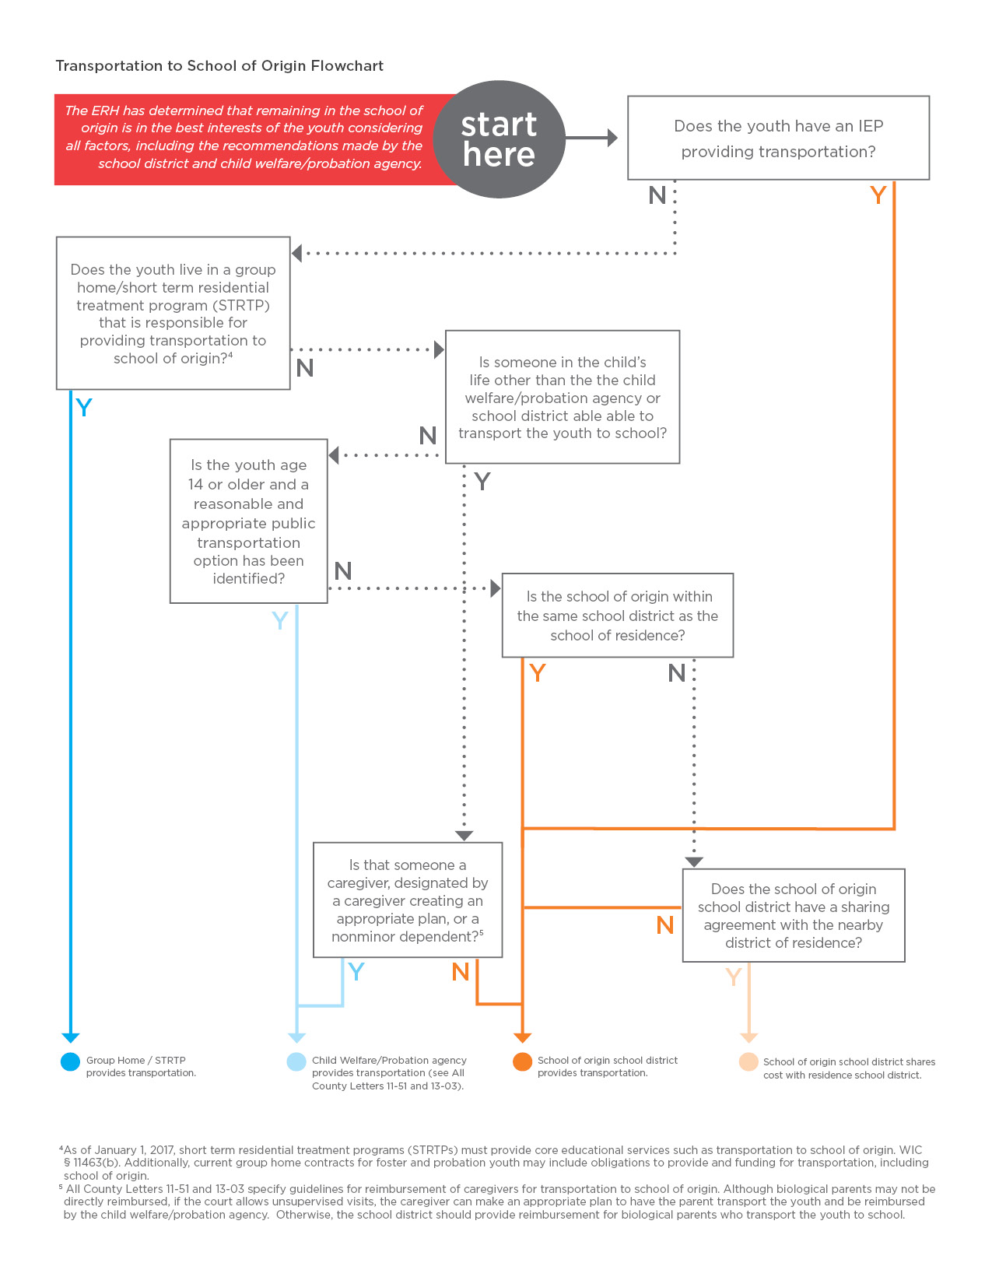

Summary of Transportation Plan
Transportation to the school of origin will be provided by:
Group Home / STRTP.
Child Welfare or Probation Agency in the form of:
Reimbursement to an individual:
Individual’s name:
Relationship to student:
Agency providing reimbursement:
Public transportation to be facilitated by the child welfare or probation agency:
The route identified is:

The School of Origin school district in the form of:
Bus or other vehicle
Reimbursement to an individual:
Individual’s name:
Relationship to student:
Public transportation to be facilitated by the school district:
The route identified is:

Other (including shared responsibility with nearby district). Describe: .
STEP 7: Consent
ERH Signature:
Student Signature:
School Administrator:

Students who have disciplinary challenges may want a “fresh start.” Unfortunately, if the underlying issues are not addressed, this may not serve the student in the long term because similar challenges may soon appear in the new setting.
School districts may establish a distance within which transportation to the school of origin is presumptively feasible, such as 15 miles. However, a student who lives further away may not be denied the right to attend the school of origin or denied access to transportation.

