# New Data

# California Foster Youth: On the Path to Irresistible Information

*September 2010*

With funding from The Stuart Foundation, the California Partnership for Achieving Student Success (Cal-PASS) partnered with researchers at University of California, Berkeley to link data from the California Child Welfare Services/Case Management System (CWS/CMS) with education data. The successful pilot project, entitled *Investigating California Foster Youth High School & College Education Outcomes*, included four California counties.

Chart 1 illustrates the number of school-aged foster youth identified in the Cal-PASS education data at each segment.[1] While the majority of linked records (43% of the original sample) fell in the K-12 category, foster youth also matched community college and university records. The overall match provides important data to investigate additional key questions and guide statewide educational advocacy efforts.

**Chart 1: Data Link Results between CWS/CMS and Cal-PASS Data Systems**

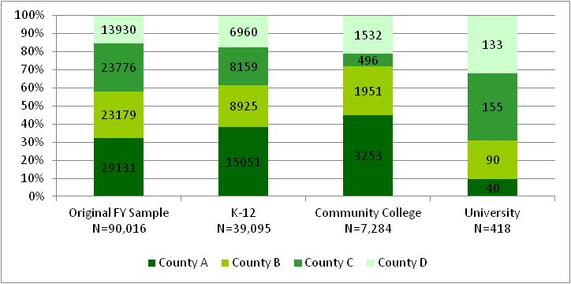

This pilot demonstrated the simple but powerful acknowledgement that a data link on this scale is not only possible, it is replicable. In the coming year, the successful pilot will be expanded statewide.

The project team will release a report on the full findings of the pilot later this winter. Preliminary findings in this summary include 8th to 11th grade California Standardized Tests (CST) scores and select college outcomes.

## Foster Youth 8th to 11th Grade Data

No Child Left Behind (NCLB) requires tracking standardized test performance for various subgroups of school children identified as “at risk” for poor academic performance (NCLB, 2001). These groups include low socio-economic status (SES), non-White, English language learners, children with disabilities, and neglected or delinquent children. While prior research indicates that the overall academic performance for foster youth is poor,[2] characteristics of foster youth and groups identified as at risk for poor academic performance often overlap[3]. It was necessary to study foster youth outcomes compared to students who share these “at risk” characteristics to more accurately understand how foster care is related to educational outcomes.

Foster youth were matched to students in the general population on key risk factors for poor academic performance. The results indicate that foster youth are less likely than their closely matched peers and the general student population[4] to achieve proficiency in English and math[5] at all grade levels (Charts 2 and 3).

**Chart 3: Math CST Percent**

**Proficient 2004-2009**



**Chart 2: English CST Percent**

**Proficient 2004-2009**



## Foster Youth College Data

Investigation of the post-secondary outcomes for foster youth in the four pilot California counties indicates that these students enroll in the lowest level remedial community college courses more often and have lower persistence and degree attainment rates than similar at-risk students (Chart 4).

In addition to the *Investigating California Foster Youth High School & College Education Outcomes* project, Cal-PASS is leading an effort to improve data access within the College Pathways Initiative.

College Pathways is a campus support program that provides former foster youth with year-round housing, financial aid, counseling and academic tutoring on 53 college campuses in California. For more information visit [www.cacollegepathways.org.](http://www.cacollegepathways.org.)

**Chart 4: Community College Outcomes**



Cal-PASS and the California State University Chancellor’s Office collected graduation[6] and persistence[7] data for 14 of the participating community college and university campuses funded by the Stuart and Walter S Johnson Foundations (Table 1). These data suggest that a majority of foster youth on these campuses who receive targeted services in college are persisting in their education.

**Table 1: College Pathways Program Outcomes**

|  |  |  |  |  |
| --- | --- | --- | --- | --- |
| **Campus** | **Year Program Began** | **Total Served** | **Graduation Rate** | **Persistence Rate** |
| University 1 | 1998 | 142 | 49% | 68% |
| University 2 | 1999 | 111 | 51% | 80% |
| University 3 | 2002 | 97 | 18% | 57% |
| University 4 | 2005 | 54 | 17% | 80% |
| University 5 | 2005 | 82 | 18% | 65% |
| University 6 | 2006 | 67 | 15% | 66% |
| University 7 | 2006 | 83 | 10% | 87% |
| University 8 | 2007 | 49 | 16% | 94% |
| University 9 | 2008 | 39 | 21% | 82% |
| University 10 | 2008 | 40 | 15% | 100% |
| Community College 1 | 2002 | 78 | 14% | 50% |
| Community College 2 | 2008 | 335 | 10% | 64% |
| Community College 3 | 2008 | 77 | 1% | 61% |
| Community College 4 | 2009 | 54 | 4% | 93% |
| **Total** |  | **1,308** | **19%** | **71%** |

To understand the College Pathways participants’ persistence in context of other college students, the foster youth persistence rate is compared to an estimate of the national persistence rate of 56%[8] (Chart 5). Former foster youth who participate in these College Pathways are persisting at a higher rate in college than non foster youth students nationwide. In the coming year, this project also will be replicated statewide, providing persistence and college success data for foster youth across a majority of the state’s universities and community colleges.

**Chart 5: College Pathways Participants Persistence Rate**

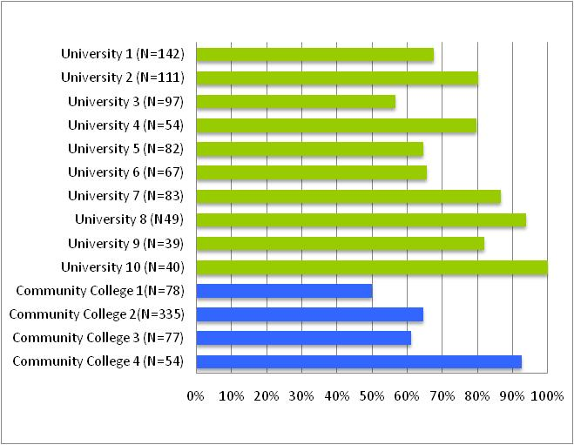

*National Persistence Average 56%*

## References

Barnettt, D., Vondra, J., & Shonk, S. (1996). Self-perceptions, motivation, and school functioning of low-income maltreated and comparison children. *Child Abuse and Neglect, 20*(5), 397-410.

Berkner, L., He, S., & Cataldi, E. (2002). *Descriptive summary of 1995-96 Beginning Postsecondary Students: Six years later*. Washington, DC: National Center for Education Statistics.

Burley, M., & Halpern, M. (2001). *Educational attainment of foster youth: Achievement and graduation outcomes for children in state care*. Olympia, WA: Washington State Institute for Public Policy.

Conger, D., & Rebeck, A. (2001). *How children's foster care experiences affect their education*: Vera Institute of Justice: New York Administration for Children's Services

Duncan, G. J., & Magnuson, K. A. (2005). Can family socioeconomic resources account for racial and ethnic test score gaps? *Future of Children, 15*(1), 35-54.

Hill, R. B. (2006). Synthesis of research and disproportionality in child welfare: An Update. Casey-SCCP alliance for racial equity in child welfare system. Retrieved January 2, 2008, available from http://www.cssp.org/major_initiatives/ racialEquity.html

Leiter, J., & Johnson, M. (1994). Child maltreatment and school performance. *American Journal of Education, 102*(2), 154-189.

No Child Left Behind Act of 2001, 20 U.S.C. § 6319.

Smithgall, C., Gladden, R., Howard, E., George, R. & Courtney, M. (2004). Educational experiences of children in out-of-home care. Published by Chapin Hall Center for Children.

Wulczyn, F., Smithgall, C. and Chen L. (2009). Child Well-Being: The Intersection of Schools and Child Welfare. In *Review of Research in Education: Risk, Schooling, and Equity*. Eds. Gadsden, V., Davis, J. E., Artiles, A. J. Vol 33, 35-62.

1. Due to districts/institutions that agreed to participate in the project, match rates between child welfare and education data vary by county.
2. Burley & Halpern, 2001; Conger & Rebeck, 2001; Smithgall, Gladden, Howard, George, & Courtney, 2004
3. Barnett, Vondra, & Shonk, 1996; Duncan & Magnuson, 2005; Leiter & Johnson, 1994; Hill, 2006; Wulczyn, Smithgall, & Chen, 2009.
4. The General Population calculations are from the California Department of Education, <http://star.cde.ca.gov>. The percentages represent the average proficiency rate (advanced or proficient) by grade level across five years.
5. Proficiency in English and math is measured by the percentage of students who scored advanced or proficient on the California Standardized Tests (CST) from 2004 to 2009.
6. Graduation rate is the percentage of students who received an Associate degree, Bachelor degree, or certification.
7. Persistence rate is the percentage of students who graduated or were still enrolled in school at the end of the school year.
8. The Beginning Postsecondary Students (BPS) Longitudinal Survey (Berkner, He, & Cataldi, 2002). study conducted by the National Center on Education Statistics followed a representative sample of first-time undergraduates from the time they entered college in the fall of 1995 though the spring of 2001.