GOVERNMENT OF THE DISTRICT OF COLUMBIA

Child and Family Services Agency

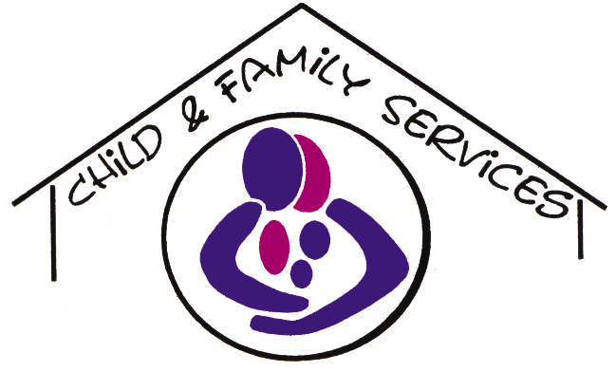

**Administrative Issuance:** CFSA-10-10

TO: All CFSA and Private Agency Staff

FROM: Cheryl Williams, M.D., Deputy Director for the Office of Clinical Practice

DATE: October 8, 2010

RE: Completion of Education/Vocation Assessments

The Child and Family Services Agency (CFSA) is dedicated to comprehensive planning for all children and youth served by CFSA, including provision of educational services for all age groups and support with vocational planning and preparation for older youth in care. Education is a critical indicator of a child’s well being. It is therefore important to review educational performance for children on an ongoing basis. Likewise, vocational services and supports are an essential part of transition planning for older youth to ensure that youth are adequately prepared for sustainable employment before, during and after their transition from foster care.

One way the Agency addresses educational performance is through the use of the CFSA Education/Vocation Assessment. The assessment is a strategic tool for obtaining essential information on a child or youth’s educational and/or vocational needs and progress, in addition to their maximized use of quality educational or vocational services.

At all times, social workers are expected to be knowledgeable of their cases and prepared to respond to detailed and pointed questions relating to a child’s needs matched with quality services. The Education/Vocation Assessment facilitates the knowledge of the worker in regard to educational and vocational needs. The information collected on the assessment will also be used on an ongoing basis to develop baselines on the educational performance and educational needs of the children served by the Agency.

This administrative issuance outlines the protocol for completion of the Education Assessment. The Education/Vocation Assessment will assist social workers in identifying academic strengths and deficiencies for children and youth involved with CFSA. The Education/Vocation Assessment will also assist social workers in identifying and documenting appropriate vocational services for older youth in care, including occurrence of vocational assessments and referrals to or completion of vocational training.

Educational and vocational information gathered must be entered on the Education/Vocation Assessment form as well as on the Client Education Screen and case planning screens in FACES. The Education/Vocation Assessment document will be used by the Office of Clinical Practice (OCP), the Office of Youth Empowerment (OYE) and other staff at CFSA and the private agencies to provide information on the educational and vocational status and needs of children and youth. In addition, the assessment assists CFSA and private agencies in meeting and documenting new federal requirements for educational services and funding.

Educational and vocational information must also be updated in FACES at critical points during the life of a case, such as after every school placement change, at the end of each marking period, when there is a new or updated IEP, following each transition planning meeting organized by the Office of Youth Empowerment (OYE) or other case managing entity or at other times when the Education Assessment is updated. In any case, the Education/Vocation Assessment form **must** be updated at the time intervals identified below and whenever there is a change in the educational decision-maker. As always, *if it isn’t in FACES, it didn’t happen.*

If you have any questions regarding this issuance, please contact your program manager.

The assigned social worker must complete the following steps for both in-home and out-of-home children on his or her caseload:

1. Complete the appropriate Education/Vocation Assessment form for every school-aged child/youth (5-18 years old) on your caseload. Complete one form per child (please do not complete one form for an entire sibling group).
2. Complete the appropriate Education/Vocation Assessment form for every youth on your caseload aged 18-21 years old, regardless of their educational or vocational status.

*Note: when completing the Education/Vocation Assessment for youth 18-21 years old, the Educational/Vocational Services for Older Youth sections* ***must*** *be completed in full and submitted at least twice a year at the time intervals identified below.*

1. All educational assessments must be reviewed and approved by the assigned supervisory social worker.
2. An initial assessment should also be completed for each child or youth within 30 days of entering foster care or within 30 days of opening an in-home case, unless the regular time interval for completing an assessment is within 60 days (see below for submission dates).
3. Place a hard copy of the completed form in each case record, in Section D.
4. Update educational and/or vocational information on the appropriate screen(s) in FACES.
5. Supervisors shall email the completed form to [cfsa.EdAssess@dc.gov](mailto:cfsa.EdAssess@dc.gov).
6. When appropriate, submit a referral to OCP for educational support services when you determine there may be additional educational needs for a child(ren), for educational consultation and/or planning purposes. Email the completed form to [cfsa.ftmu@dc.gov](mailto:ftm@dc.gov).
7. When appropriate, please consult with the vocational specialist(s) in the Office of Youth Empowerment (OYE) regarding available vocational supports and services.
8. All forms shall be completed for each client twice a year, submitted no later than November 15th and April 15th, to best capture educational performance and progress throughout the year.