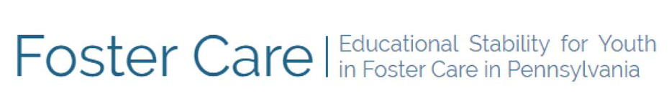

Thank you for serving as your school’s foster care point of contact. We have developed a short survey to collect information on key implementation areas of the Every Students Succeeds Acts Title I, Part A foster care provisions for the 2019-2020 school year. Responses should capture information collected through March 13, 2020, the last day of in-school operations before the announcement of statewide K-12 school building closures in PA due to COVID-19. Your survey responses will help us identify areas where additional guidance may be needed to improve educational stability.

Please note, each question requires a response. While you can edit your responses by clicking “back” throughout the survey, your responses will not be saved if you exit the survey before submission.

Thank you for taking the time to complete the survey.

Please provide your contact information:

First name Last name LEA
Email

Response

Part I. School Placement Best Interest Determinations (BIDs)

Has your school district participated in any school placement Best Interest Determinations (BIDs) since the beginning of the 2019-2020 school year through March 13, 2020?

Please enter a number OR check one or more "No" reasons.

Yes
Enter the number of BIDs here
Yes, but unsure of number of BIDs
No, we did not have any students in foster care No, we were not invited to participate in BIDs
No, we did not feel it was necessary to participate in BIDs No, for other reasons
Don't know

If you answered YES in the previous question, what number of students remained in their school district of origin?

Number remaining
Unsure of the number remaining Not applicable

Please list the three most frequent reasons students enrolled into a new school district of foster residence (district where child is laying head in foster care placement).

Each box requires a response. Type N/A if no response.

First reason:
Second reason:
Third reason:

Reason for Enrollment in a new district:

Back
Continue

Part 2. Transportation for Youth in Foster Care
Transportation for students in foster care is required if it is needed to provide school stability.

For how many students in foster care have you arranged, provided, or funded transportation since the beginning of the 2019-2020 school year through March 13, 2020, in order to remain in the school district/school of origin?

Enter the number of students with arranged, provided, or funded transportation
Unsure
Not applicable (did not make such arrangements)

Among the number of students you reported above, how many cases incurred ADDITIONAL transportation costs for your school district?
(Does not include no cost transportation such as utilizing existing routes or regular transportation subsidies.)

Number with additional transport costs Unsure
Not applicable (did not make such arrangements)

Part 3. Challenges

How much of a challenge is providing, arranging, and/or funding transportation?

Extremely challenging Very challenging Moderately challenging Somewhat challenging Not a challenge

Please describe what would make providing, arranging, and/or funding transportation less challenging. Type N/A if not applicable.




How much of a challenge is identifying youth in foster care in your school/school district?

Extremely challenging Very challenging Moderately challenging Somewhat challenging Not a challenge

Please describe what would make identifying youth in foster care in your school/school district less challenging. Type N/A if not applicable.




How much of a challenge is ensuring that best interest determinations (BIDs) are collaborative?

Extremely challenging Very challenging Moderately challenging Somewhat challenging Not a challenge

Please describe how the BID process could be more collaborative. Type N/A if not applicable.




Youth in foster care are entitled to immediate enrollment, even if records normally required for enrollment are not available.
How much of a challenge is immediately enrolling youth in foster care in your school/school district?

Extremely challenging Very challenging Moderately challenging Somewhat challenging Not a challenge

Please describe how enrolling youth in foster care immediately in your school/school district could be less challenging. Type N/A if not applicable.




Back
Continue

Part 4. General Feedback

Please identify any topics for future statewide or regional professional development to better equip you in your role as a school foster care point of contact.




Please provide any additional comments.




Would you like to be contacted by the state foster care point of contact, or your regional foster care office, to further discuss your survey responses?

Yes please indicate reason for follow-up
No

Back
Submit

Thank you for completing the School Foster Care Point of Contact survey!

